Tutorial 02

**Exercise 1**

i)

//Using variables in printf statements

#include<stdio.h>

int main(void)

{

int x=2, y=3; //values are assumed for the variables

printf("*\n**\n****\n*****\n");

return 0;

}//end of the main function

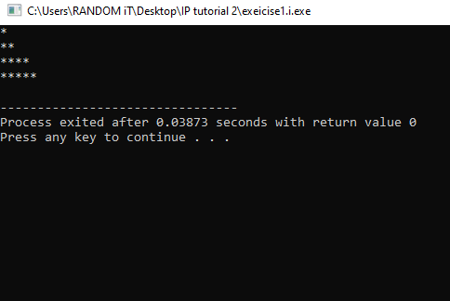

ii)

//Using variables in printf statements

#include<stdio.h>

int main(void)

{

int x=2, y=3; //values are assumed for the variables

printf(" %d",x+x);

return 0;

}//end of the main function

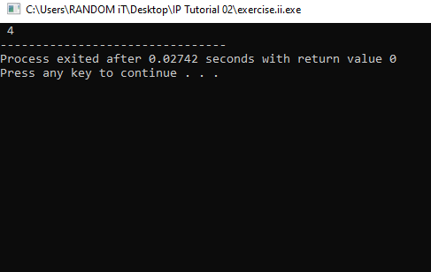

iii)

//Using variables in printf statements

#include<stdio.h>

int main(void)

{

int x=2, y=3; //values are assumed for the variables

printf("x=");

return 0;

}//end of the main function

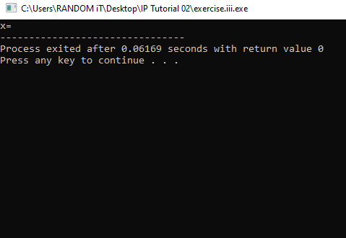

iv)

//Using variables in printf statements

#include<stdio.h>

int main(void)

{

int x=2, y=3; //values are assumed for the variables

printf("x=%d",x);

return 0;

}//end of the main function

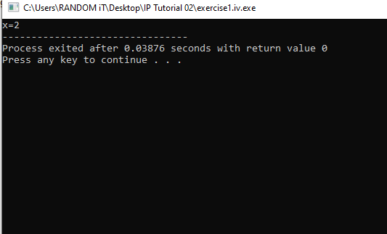

**v)**

//Using variables in printf statements

#include<stdio.h>

int main(void)

{

int x=2, y=3; //values are assumed for the variables

printf("%d=%d,x+y,y+x");

return 0;

}//end of the main function

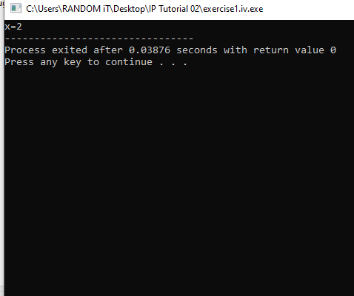

**vi)**

//Using variables in printf statements

#include<stdio.h>

int main(void)

{

int x=2, y=3; //values are assumed for the variables

/*printf("%d",x+y);*/

return 0;

}//end of the main function

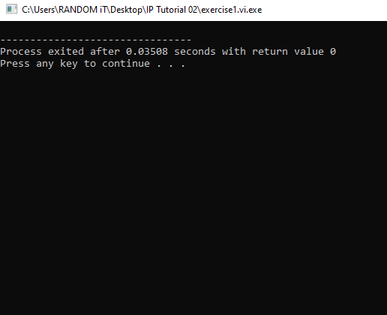

**vii)**

//Using variables in printf statements

#include<stdio.h>

int main(void)

{

int x=2, y=3; //values are assumed for the variables

printf("\n");

return 0;

}//end of the main function

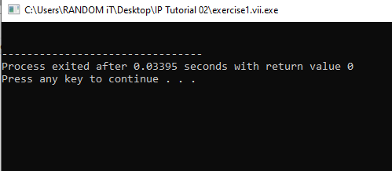

**viii)**

//Using variables in printf statements

#include<stdio.h>

int main(void)

{

int x=2, y=3; //values are assumed for the variables

float z=45.567;

printf("value is %.2f",z);

return 0;

}//end of the main function

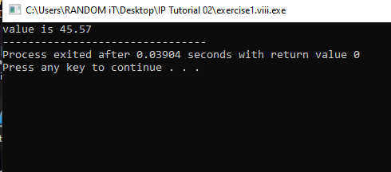

**Exercise 2**

**a)**

//this programe display number formatting

#include<stdio.h>

int main(void)

{

printf(" %.2f\n",3.446); //Dislay the n value with 2 digits precision

printf(" %.1f\n",3.446); //Dislay the value with 1 digit precision

return 0;

}//end of main function

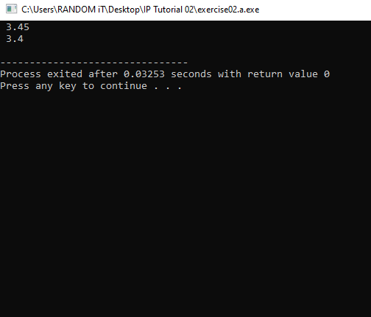

**b)**

//This programe display the number formatting

#include<stdio.h>

int main(void)

{

printf(" %.2f\n",123.4567);//Dislay the value with 2 digits precision

printf(" %.3f\n",3.14159);//Dislay the value with 3 digit precision

printf("%15.1f\n",333.546372);//Dislay the value in field width

printf("%15.2f\n",333.546372);

printf("%15.3f\n",333.546372);

printf("%15.4f\n",333.546372);

printf("%15.5f\n",333.546372);

return 0;

}//end of the main function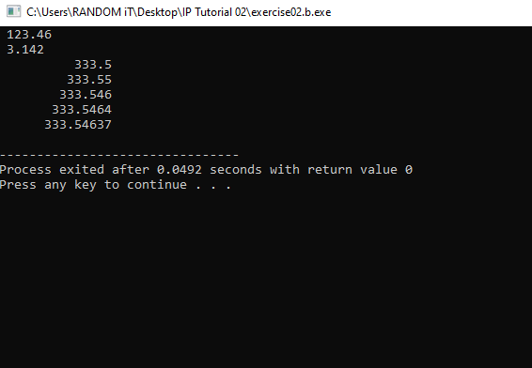

**Exercise 3**

i)

//Using scanf statement in C programe

#include<stdio.h>

int main(void)

{

int mark1=0, mark2=0;

printf("Enter Mark 1=");

scanf("%d",&mark1);

printf("Mark 1: %d\n",mark1);//Dislay the mark1

printf("Enter Mark 2=");

scanf("%d",&mark2);

printf("Mark 2: %d\n",mark2);//Dislay the mark2

return 0;

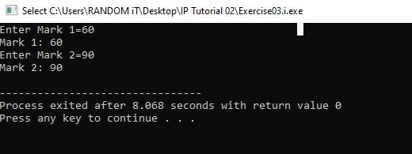}//end of the main function

**ii)**

//Using scanf statement in C programe

#include<stdio.h>

int main(void)

{

int mark1=0, mark2=0, total=0;

printf("Enter Mark 1=");

scanf("%d",&mark1);

printf("Enter Mark 2=");

scanf("%d",&mark2);

total=mark1+mark2;//Sum of two marks

printf("Total=%d",total);//Display sum

return 0;

}//end of the main function

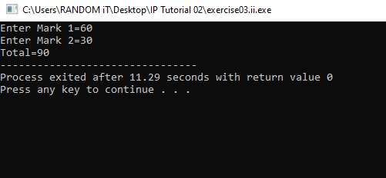

**iii)**

//Using scanf statement in C program

#include<stdio.h>

int main(void)

{

int mark1=0, mark2=0;

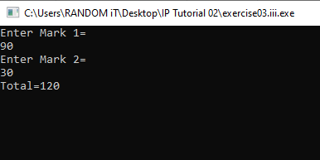 printf("Enter Mark 1= \n");

scanf("%d",&mark1);

printf("Enter Mark 2= \n");

scanf("%d",&mark2);

float total=mark1+mark2;

printf("Total=%.2f\n",total);

scanf("%.2f",&total);

float average=total/2;

return 0;

}//end of main function

**iv)**

//This programe display the average mark

#include<stdio.h>

int main(void)

{

int mark1=0, mark2=0;

float total=0, average=0;

printf("Enter Mark 1=\n");

scanf("%d",&mark1);

printf("Enter Mark 2=\n");

scanf("%d",&mark2);

total=mark1+mark2;

printf("Total=%.2f\n",total);

average=total/2;

printf("Average=%.2f\n",average);//Dislay average

return 0;

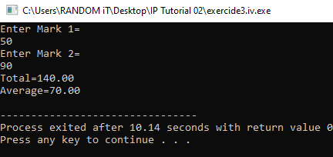}//end of main function

**Exercise 4**

#include <stdio.h>

struct item

{

int itemNo;

double price;

int quantity;

};

int main()

{

struct item Item1; /* Declare Item1 of type item */

struct item Item2; /* Declare Item2 of type item */

//using struct 1

printf("Enter item No:");

scanf("%d", &(Item1.itemNo));

printf("Enter the price:");

scanf("%lf", &(Item1.price));

printf("Enter the quantity:");

scanf("%d", &(Item1.quantity));

//using struct 2

printf("Enter item No:");

scanf("%d", &(Item2.itemNo));

printf("Enter the price:");

scanf("%lf", &(Item2.price));

printf("Enter the quantity:");

scanf("%d", &(Item2.quantity));

//printing the table

printf(" ItemNo\t\tPrice\t\tQuantity\n");

printf("%d\t\t%.2lf\t\t%d\n", Item1.itemNo, Item1.price, Item1.quantity);

printf("%d\t\t%.2lf\t\t%d", Item2.itemNo, Item2.price, Item2.quantity);

return 0;

}

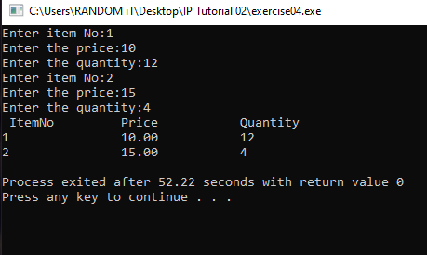

Perera V.G.K.B.S

IT21387630